

|  |  |  |
| --- | --- | --- |
| **MATHEMATICS DEPARTMENT** | |  |
| **Course:** **ATMAA** | |
| **Topic Title**: **Skills Test 6** | |
| Student Name:_____________________________________ | Date: __________2016 | | |
| Special Instructions: No Calculators | Time Allowed: 15 mins | | |
|  | Marks: / 10 | | |

**Question 1**

Write down the first four terms of the sequence if *a*1 = 1 and *an*+1 = 2*an* + 4.

A 0, 4, 12, 28 B 1, 4, 10, 18 C 1, 4, 12, 28

D 1, 6, 16, 36 E 6, 16, 34, 72

**Question 2**

A sequence is defined by *tn*+1 = *atn* + 3 where *t*1 = 8. For what value of *a* will the sequence have a long-term steady state solution of 6?

A $a=0.4$ B $a=0.5$ C $a=-0$

D $a=0.6$ E $a=-0.6$

**Question 3**

A recurrence relation generates the arithmetic sequence 5, 9, 13, 17, ... Find a rule for the *n*th term of the sequence.

A $t_{n}=n+4$ B $t_{n}=4n-3$ C $t_{n}=4n+1$

D $t_{n}=4n+5$ E $t_{n}=5n+4$

**Question 4**

Given the recurrence relation *tn*+1 = 2*tn* + 3 and *t*3 = 25, find *t*6.

A 109 B 206 C 221

D 315 E 445

**Question 5**

Which of these is the explanatory variable and which is the response variable?  
  
Consider ‘plant yield’ and ‘amount of fertiliser’.

|  |  |
| --- | --- |
| A | Response variable: plant yield Explanatory variable: amount of fertiliser |
| B | Response variable: amount of fertiliser Explanatory variable: plant yield |
| C | Both are response variables. |
| D | Both are explanatory variables. |
| E | They are neither response variables nor explanatory variables |

**Question 6**

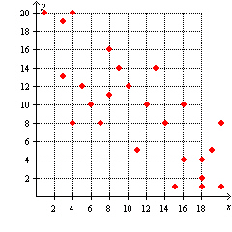What kind of a relationship could be concluded between the *x* and *y* variables from the scatter plot below?

A Strong positive

B Strong negative

C Moderate positive

D Moderate negative

E No relationship

**Question 7**

How would you describe the distribution of the following data?

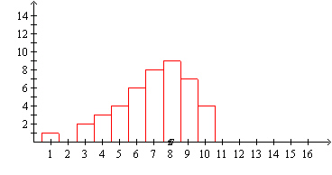A Positively skewed

B Negatively skewed

C Symmetric

D Bimodal

E There is an outlier

**Question 8**

The following is a graph of a road map. Distances are in kilometres.

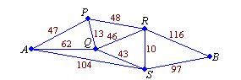Find the shortest path from *A* to *B.*

A *A-S-B*

B *A-P-R-B*

C *A-Q-S-B*

D *A-P-Q-S-B*

E *A-P-Q-R-S-B*

**Question 9**

Which one of the following graphs is Eulerian?

A 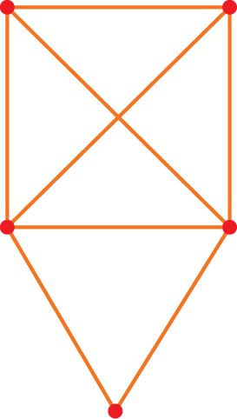 B  C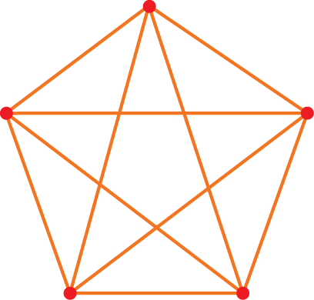

D  E 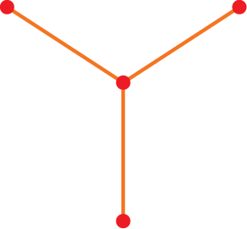

**Question 10**

Redraw this graph as a planar graph:

